
Instructor:Mam Nimra Shafqat
Group member&&id:
1)Syed Rayyan Saeed 240558
2)Shiraz khan 240550
3)Abdullah shaifal 243438
Topic: Sensitive data exposure
Report:

1. Introduction
Sensitive Data Exposure is a critical security vulnerability in which confidential information becomes accessible to unauthorized individuals. This includes usernames, passwords, credit card details, medical records, and personal data. It is considered one of the most dangerous risks. If not properly protected, sensitive data can be stolen, misused, or sold, causing serious harm to individuals and organizations.

2. Importance of Sensitive Data Protection
Protecting sensitive data is essential because:
- Personal and financial information can be misused for fraud.
- It can lead to identity theft and account takeovers.
- Organizations suffer reputation damage and loss of customer trust.
- Legal and regulatory penalties may be imposed.

3. Sensitive Data Exposure – Attack Process
The following steps explain how sensitive data exposure typically occurs:

Step 1: Attacker Initiates the Attack
An attacker creates a spear-phishing email that looks legitimate and targets a specific user. The goal is to trick the user into clicking a malicious link or opening an infected attachment.

Step 2: Email Enters the Organization
The phishing email passes through firewalls and email security filters. Due to zero-day malware, weak filtering rules, or human-focused social engineering, the email is not detected.

Step 3: User Is Compromised
The user interacts with the email, resulting in malware installation or credential theft. The attacker gains unauthorized access to the user’s system or account.

Step 4: Internal Access to Sensitive Data
Using the compromised account, the attacker accesses internal systems containing sensitive data such as:
- Social Security Numbers (SSN)
- Credit card details
- Banking and financial data
This data may be stored without encryption or protected with weak permissions.

Step 5: Security Monitoring Failure
Security tools like Proxy, IDS/IPS, and DLP attempt to inspect outgoing traffic. However, attackers encrypt their traffic or hide it within normal network activity, bypassing detection.

Step 6: Data Exfiltration
The sensitive data is transferred outside the organization. The firewall allows it because the traffic appears legitimate.

Step 7: Sensitive Data Exposure
The attacker successfully receives the stolen data, which is then exposed, misused, or sold.

4. Real-World Examples

4.1 Credit Card Data Breach (Retail Store)
Hackers send phishing emails to employees. After one employee clicks the email, attackers access the payment system and steal customer credit card information.
Exposed Data: Card numbers, CVV, customer names.

4.2 Hospital Data Leak
A hospital stores patient records without proper encryption. An attacker gains access and downloads medical records.
Exposed Data: Patient history, medical reports, IDs
Impact: Severe privacy violation (HIPAA).

5. How the Attack Happens (Flow)
- Attacker sends a fake email.
- Email looks legitimate and is trusted.
- Security tools fail to block it.
- User clicks the email link or attachment.
- Attacker gains access to the system.
- Sensitive data is located and stolen.
- Data is sent outside the organization.
- Sensitive data becomes exposed.

6. Impact of Sensitive Data Exposure
- Account Compromise: Unauthorized access to user accounts.
- Financial Loss: Fraud using banking or credit card data.
- Identity Theft: Victims are impersonated using stolen data.
- Loss of Privacy: Personal and medical information becomes public.
- Brand Damage: Organizations lose trust and face negative publicity.

7. Prevention and Protection Measures
To prevent sensitive data exposure:
- Use strong encryption (AES).
- Hash and salt passwords.
- Never store passwords in plain text.
- Use HTTPS for secure communication.
- Secure cloud storage and backups.
- Apply strong access control and permissions.
- Perform regular vulnerability scanning.
- Never hardcode API keys or passwords in source code.

8. Conclusion
Sensitive Data Exposure occurs when confidential information is not adequately protected. Common causes include plain text storage, weak encryption, and misconfigured systems. Attackers exploit exposed data to steal money, compromise accounts, and violate privacy. Implementing strong encryption and proper security practices can effectively prevent this vulnerability.

9. References
- SSL Labs Sensitive Data Exposure
https://www.ssllabs.com/ssltest/

Tool:

https://www.ssllabs.com/ssltest/
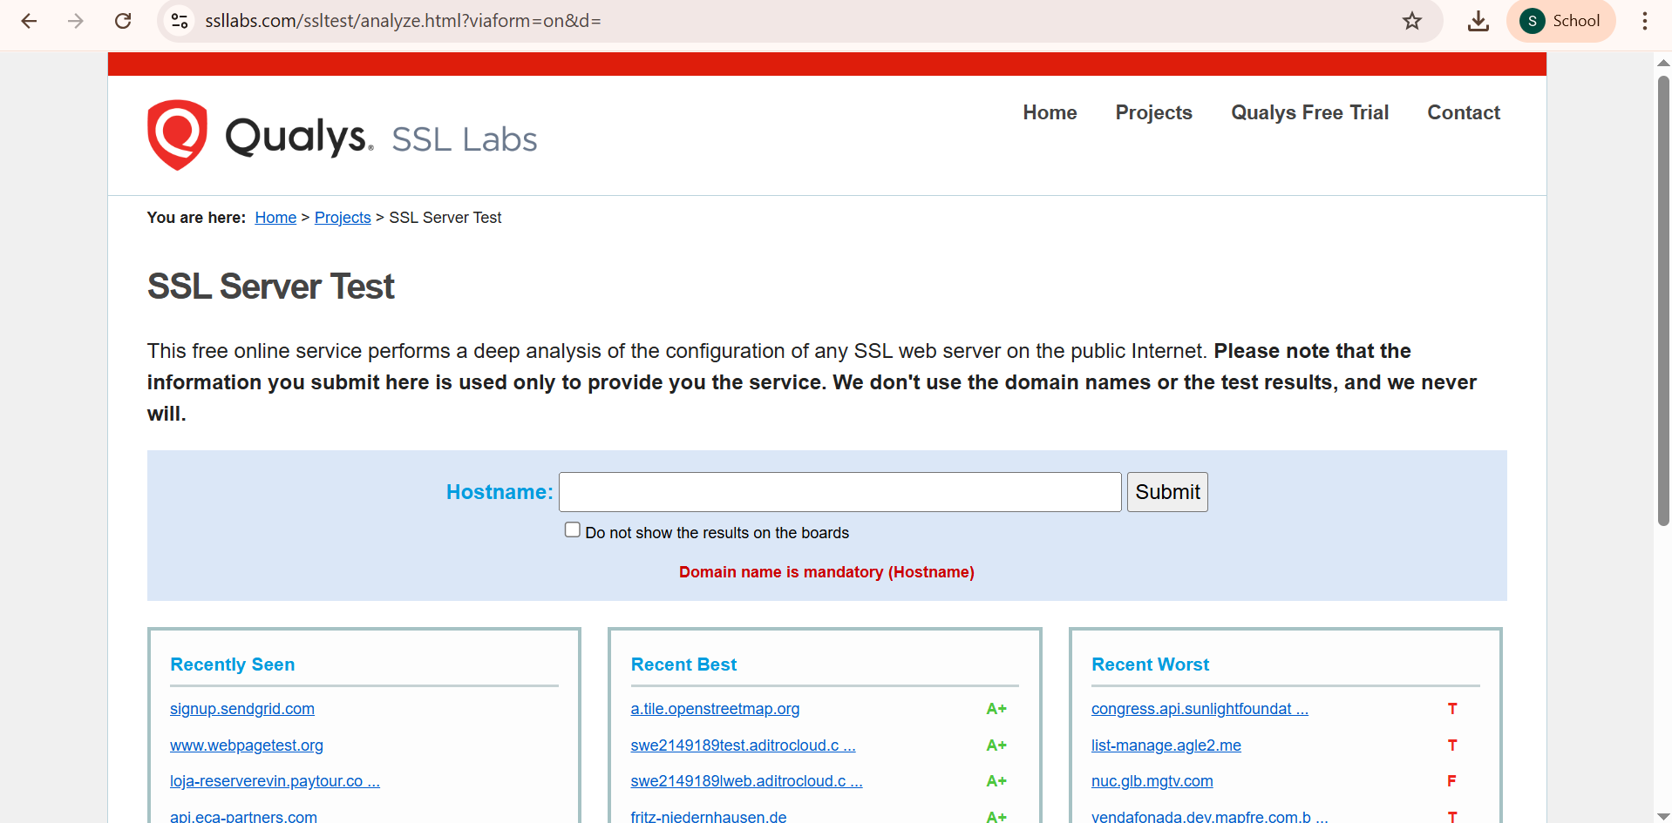
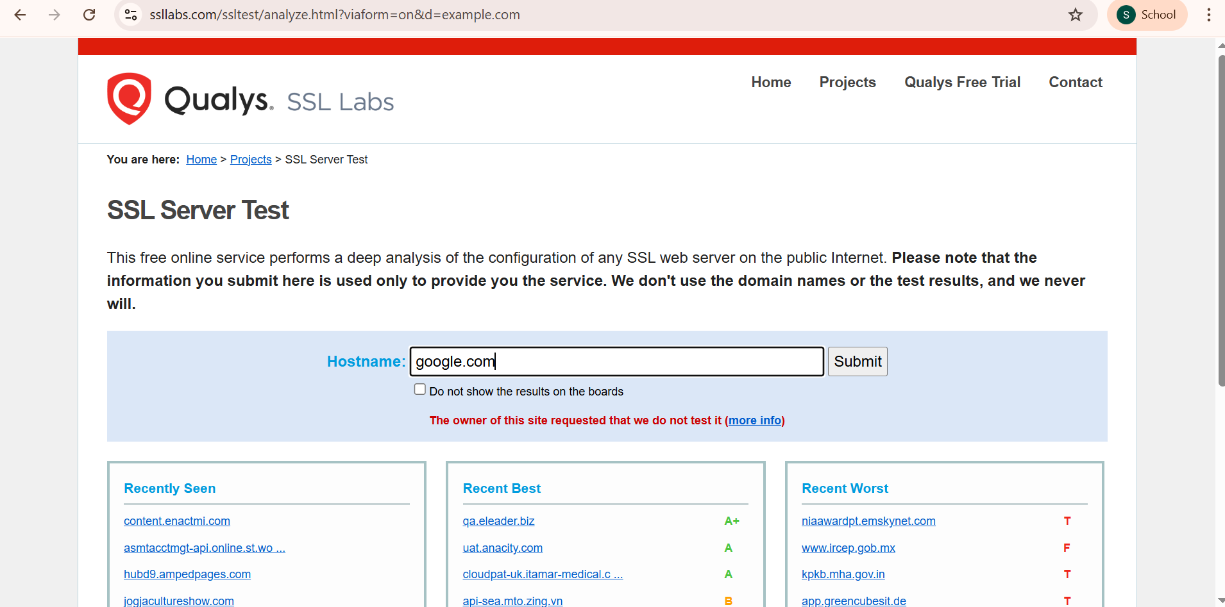
Click submit
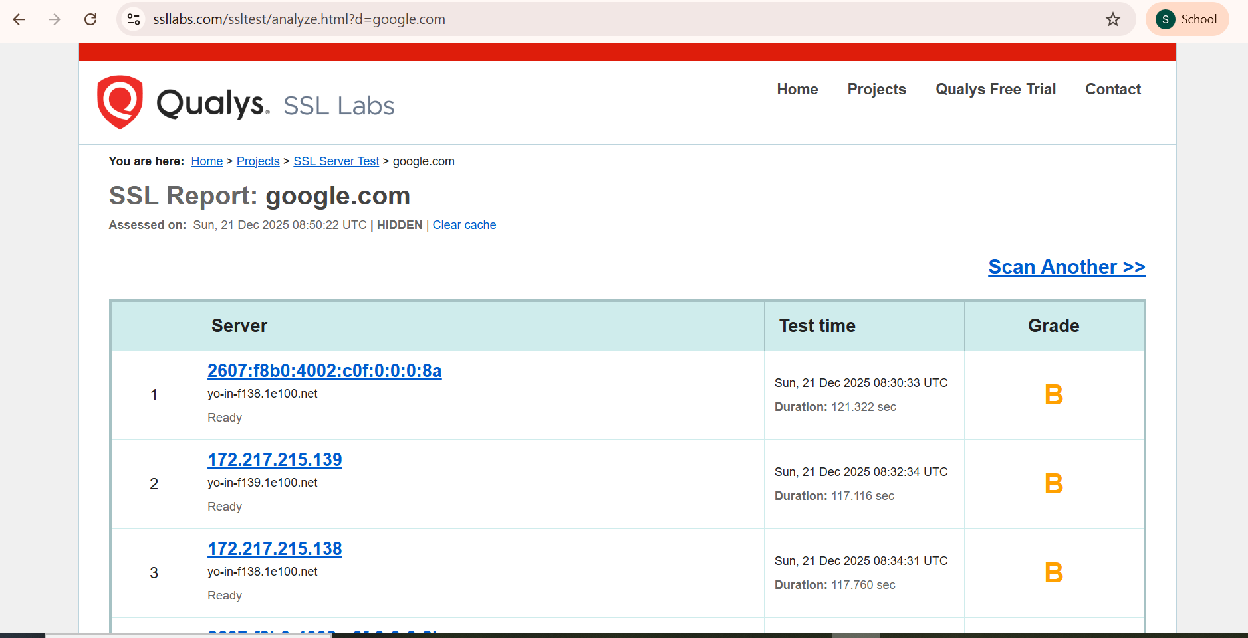
Open this:
Click on it.
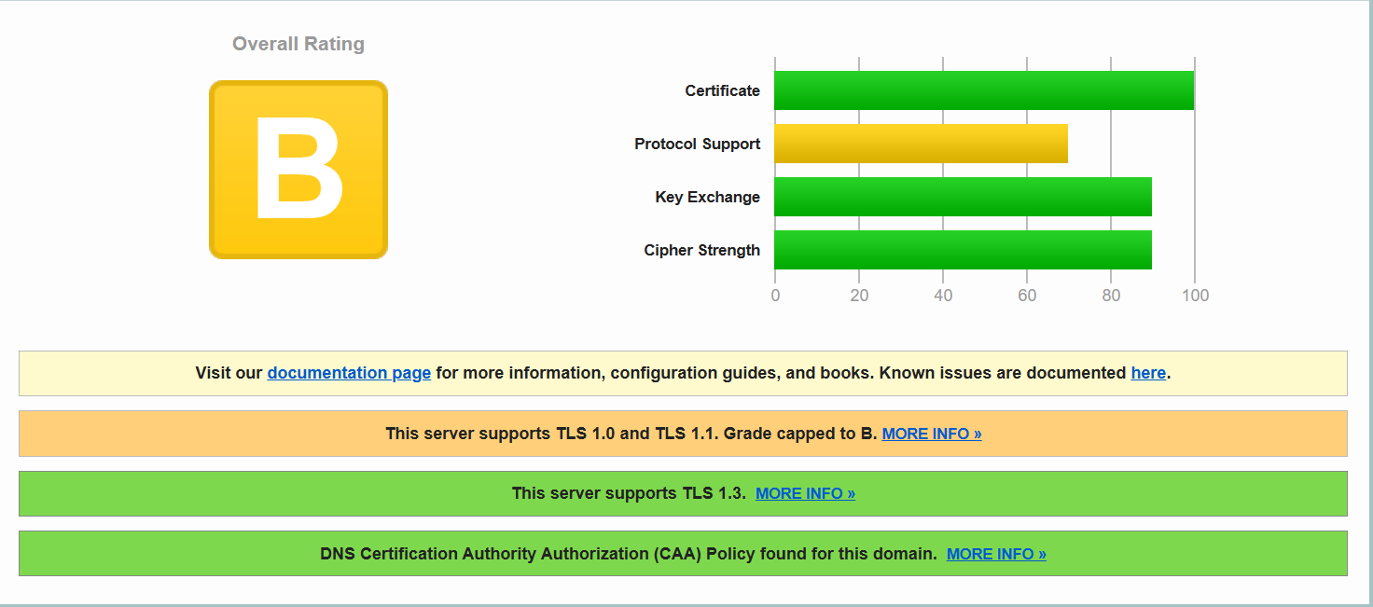

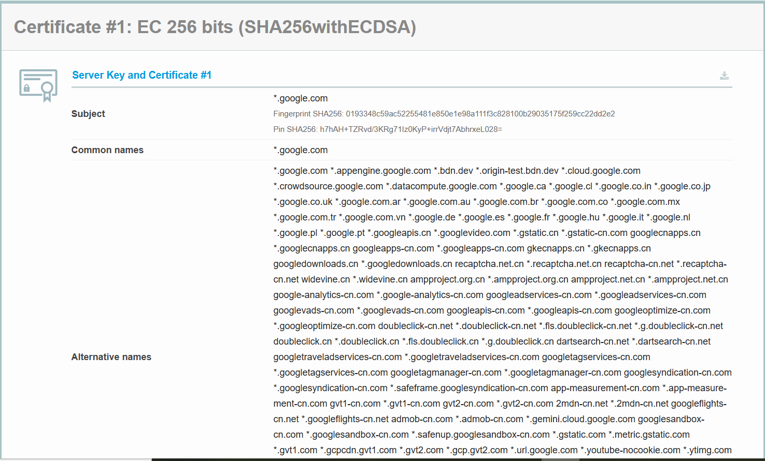
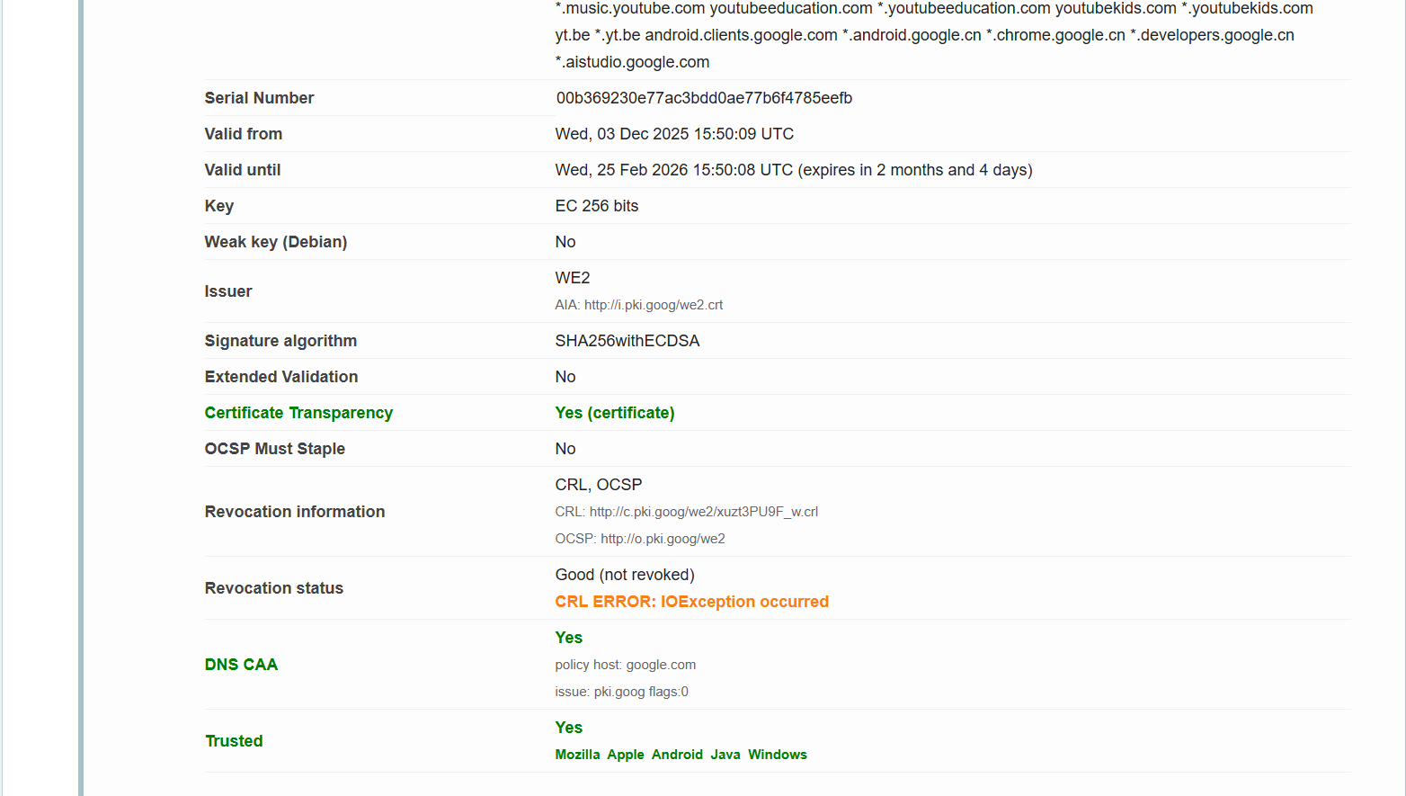
Protocol:
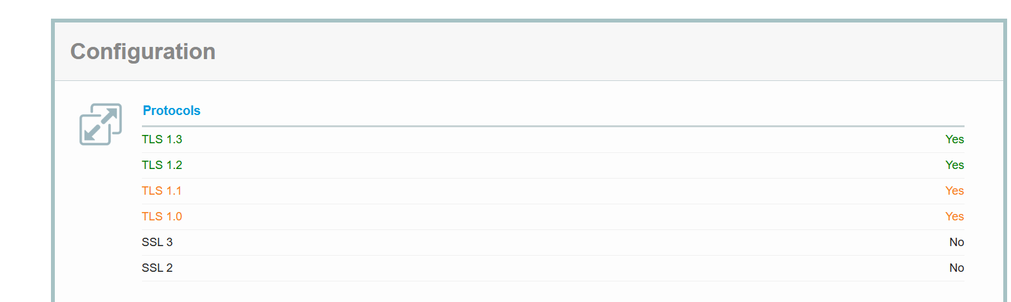

Cipher Suite:
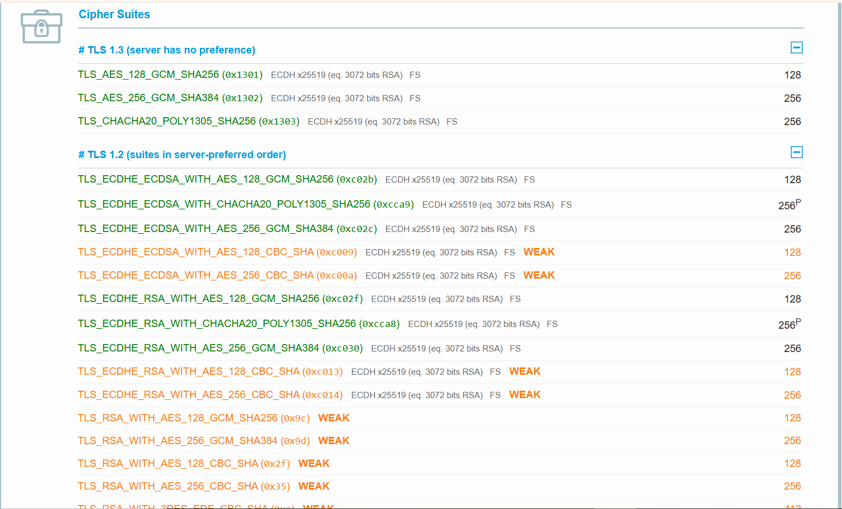
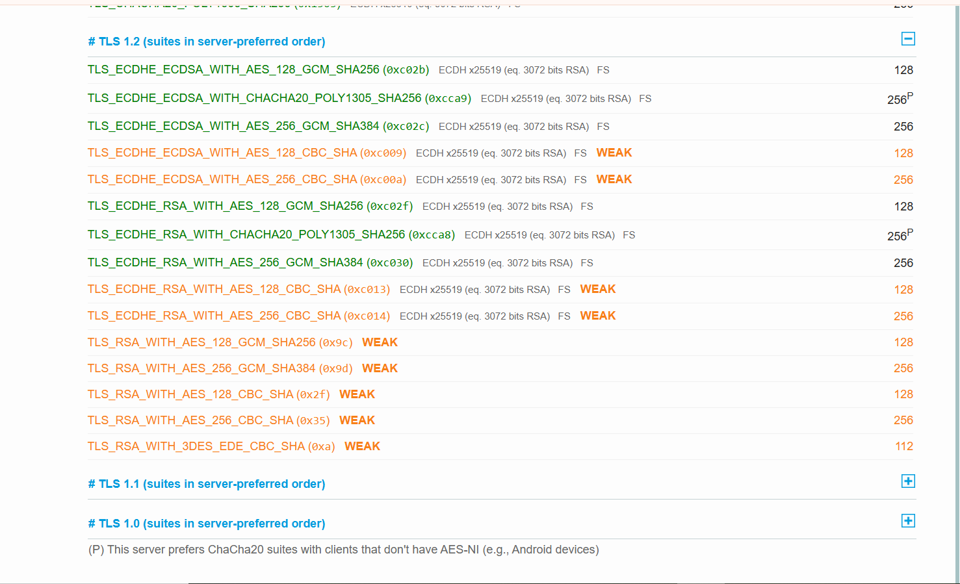
“SSL Labs analysis shows that the website uses HTTPS and SSL/TLS encryption, which helps prevent Sensitive Data Exposure by protecting data during transmission.”

